Topic 1: Characteristics of Life

1. A Tree is a living thing but Fruit is not. Explain this statement using your understanding of the life processes.

1. Movement can be body, of the body, or .
2. Cells use to move while is used to move particles along a cells surface.
3. Is the process used to break down to create it requires .
4. Is how cells can respond to and changes and maintain . it is used to cells.
5. Means a cell in size but not necessarily at an rate.
6. Comes in two forms, which is how new humans are made and which is the process used to replace worn out cells.
7. Is the process used to wastes which are produced in reactions in the body. A few examples are , and waste from protein breakdown.
8. Nutrition involves of food and drink, which breaks it down and where it is carried by blood.
9. In humans we have an extra life process called as we have cells.

Now that you have got the hang of these processes attempt the crossword below:

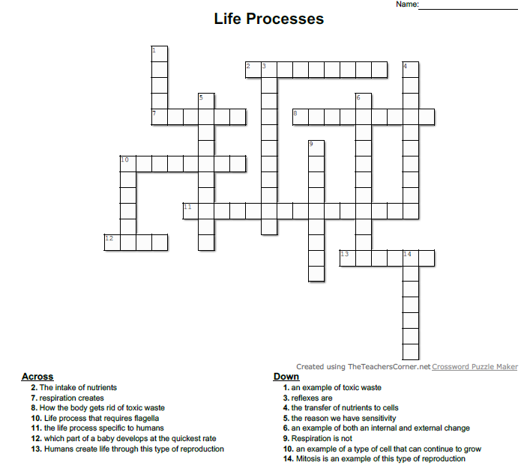

1. Label the cell below

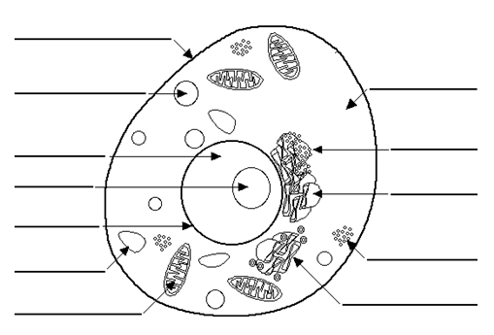

1. Explain the difference between cilia and flagella using an example.

1. The cytoskeleton is made up of and . Explain the difference between the two.

1. In your own words explain the structure and function of the cell membrane.

1. Draw a diagram to represent the phospholipid bilayer.
2. During an experiment the class said ‘the bigger the cell the better’ explain if this is correct or incorrect.

1. There are 2 main types of transport and . Explain the difference using examples.

1. Steroids and Sodium diffuse into a cell via two different methods, explain why.

1. When a cell is placed in a hypertonic solution it will lose water but in a hypotonic solution it will gain water, explain how and why this occurs. You can use diagrams to support your answer.

1. Explain using diagrams the difference between exocytosis and endocytosis

Cells to Organisms

1. Explain the difference between a unicellular organism and a multicellular organism

1. A tissue is made of cells that work to perform a specific function. An example is tissue which can be found in your .
2. Organs are made of cells that work together to perform a specific function. An example is
3. An is a group of organs that work together for example the which consists of all the bones in your body
4. In your own words explain the levels of organisation from cells to organisms.

